ESP8226 as a Secure Client of a JSON Restful service.

The Internet would have been much simpler; if everybody just trusted each others. But because of modern day security concerns, HTTP websites or Services are less and less found. That is why I find it essential to learn how to consume and parse a JSON with HTTPS.

1) SwissMetNet Project
(https://www.meteoschweiz.admin.ch/home/mess-und-prognosesysteme/bodenstationen/automatisches-messnetz.html )

It is a project to make the current weather conditions recording stations in Switzerland open for the public. There are 160 stations all over Switzerland recording and publishing their data every 10 minutes. This data is published via OpenDataSMN API https://opendata.netcetera.com/smn/ .
A Swagger documentation is available here: https://opendata.netcetera.com/smn/swagger#!/smn/getSmnRecord_get_2

In short , we are going to fetch the data of only 1 station (Bern /Zollikofen), please try the following URL in your browser:
http://opendata.netcetera.com/smn/smn/BER
notice the result page, which is a JSON response.
Notice the structure of the JSON and look for Temperature and Humidity fields.

2) HTTPS:
For every HTTPS website there is certificate and SHA-1 Fingerprint.
You will notice that the HTTP URL above redirects to an HTTPS one.
Now click on the lock icon next to the URL in the address bar. From there (depending on your browser) try to find the fingerprint of the Certificate till you find the “SHA1 Fingerprint”

In Firefox: press the green lock on the address bar next to the Https:// url and view the Certificate, look for SHA1 "Fingerprint"

In Chrome: press the lock on the address bar next to the Https:// url look for certificate details and you will find it under the name "Thumbprint"

The Fingerprint of the opendata.netcetera.com would look something like this:
63e90ab49c379653aed3d0c5b5e10bddbd9a05f3
or
63:E9:0A:B4:9C:37:96:53:AE:D3:D0:C5:B5:E1:0B:DD:BD:9A:05:F3

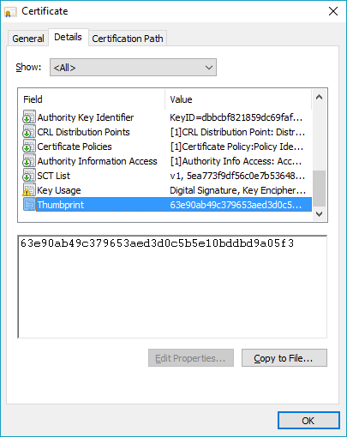 | 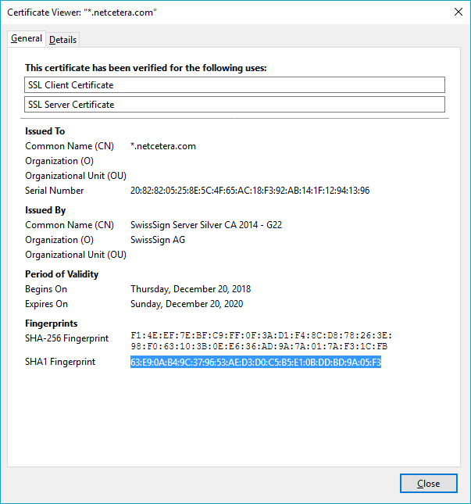 | 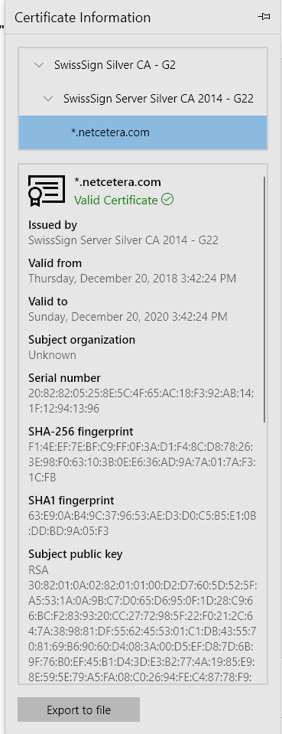
Chrome | Firefox | Microsoft Edge

To see a sample code of the ESP8266 acting as an HTTPS client:
File→ Examples → ESP8266HTTPClient → BasicHttpsClient

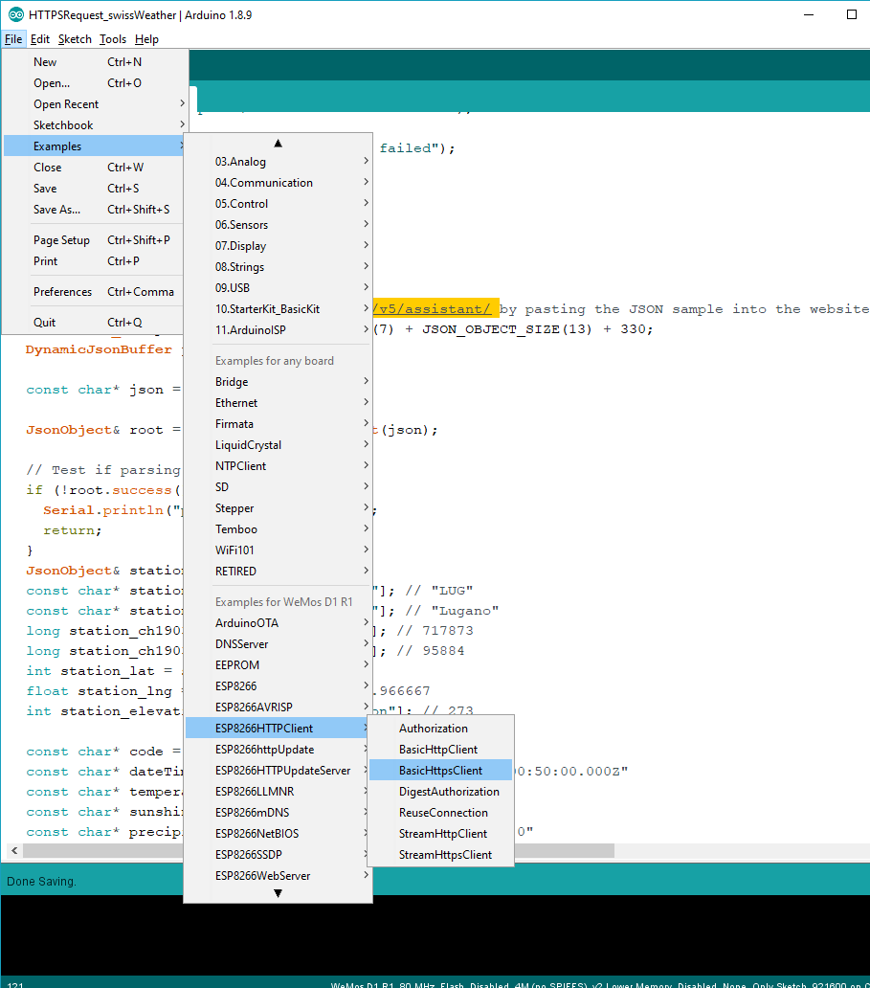

3) Parsing the JSON:
Edge or constrained devices such as the ESP8266 and other Microcontorllers are short on processing and memory. And Processing a JSON or XML structure is rather a challenging task. The developer has to be very aware of the size the returned JSON structure and plan his steps well.
For processing the JSON, we are going to use the ArduinoJSON library.
This library comes with a web page that can evaluate the proper sizing of a JSON structure and define the capacity of this structure. https://arduinojson.org/v5/assistant/

To get and Capacity of the JSON variable and get an automatically generated code snippet of how to parse and process a JSON, just copy the sample JSON you have from the opendata smn url above into the “Input” of the webpage. For best reliable results, first “view-source” of the json page and then paste that source in the “Arduinojson.org” page.

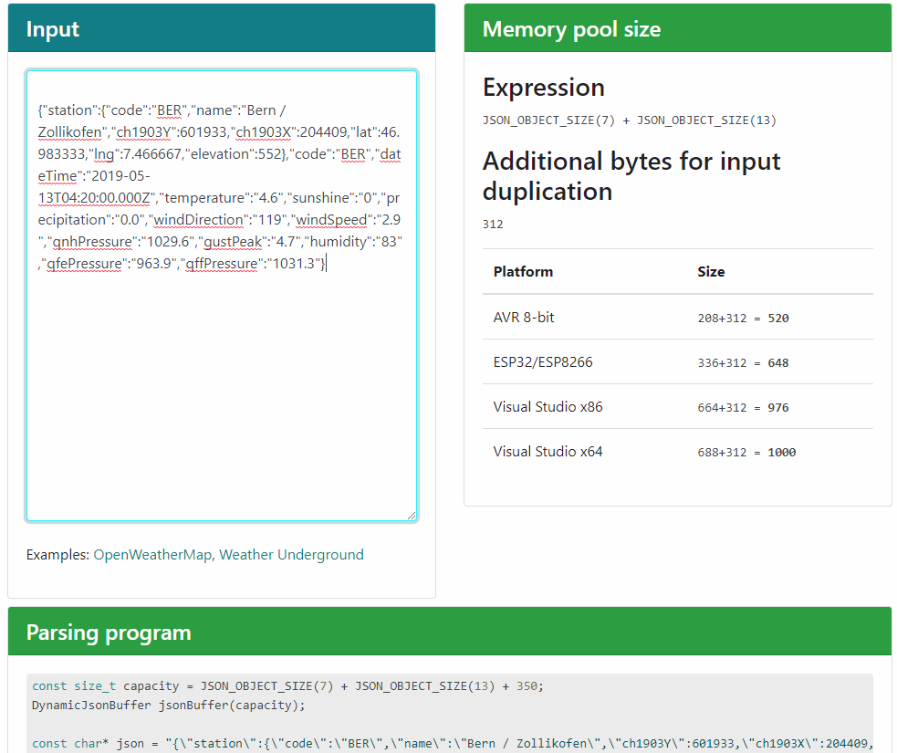

There are two further sections below in the web page showing how to parse and how to serialize such a JSON.

To use the json library, you have to install it first in the Arduino IDE. Please install version 5 not version 6. as this is required by the Telegram Library.

You could browse around the different ArduinoJson Examples, or you could just open and try out the sketch “HTTPSRequest_swissWeather”. Try to pick a different station.
To get more station codes and compare your results, try using this website https://iday.ch .

